Searching the best place for starting a new coffee shop in Seoul, South Korea

Jaecheol Hwang

1. Introduction

1.1 Background

As of July 2019, in South Korea, there were 71,000 Coffee shops. And the number of Coffee shops are increasing even now. However, many of them were closed before 3 years.

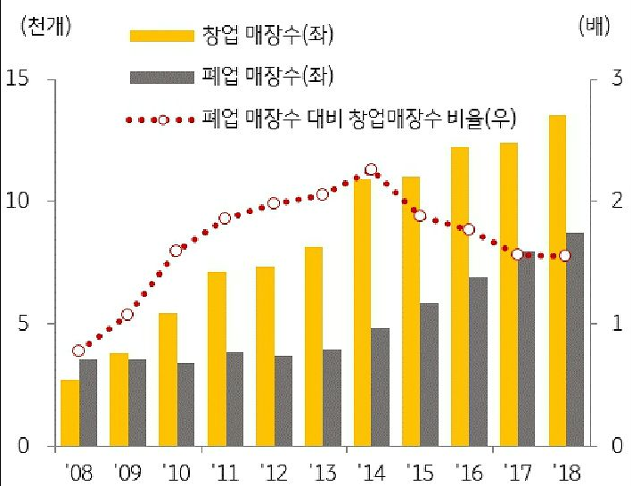

Fig. 1. Number of start-up and shut-down coffee shop in South Korea. [[link]](https://www.nocutnews.co.kr/news/5238987)

It means that many people tried to open coffee shop but a few of them succeed to keep their shop. Then does we just give up to open our own coffee shop? My answer is NO There are report, column, or wikipedia page about coffee culture of South Korea. We don't need to give up now, however we should know that points of the success.

I want to find the points using geographic data and Foursquare location data, and figure out which area is the most potential for starting coffee shop.

1.2 Problem Statement

* In Seoul, South Korea, where is the best place for starting a new coffee shop?
* Seoul has 25 Districts/Counties("Gu", in korean) and Districts are separated to several Cities/Towns("Dong", in korean).

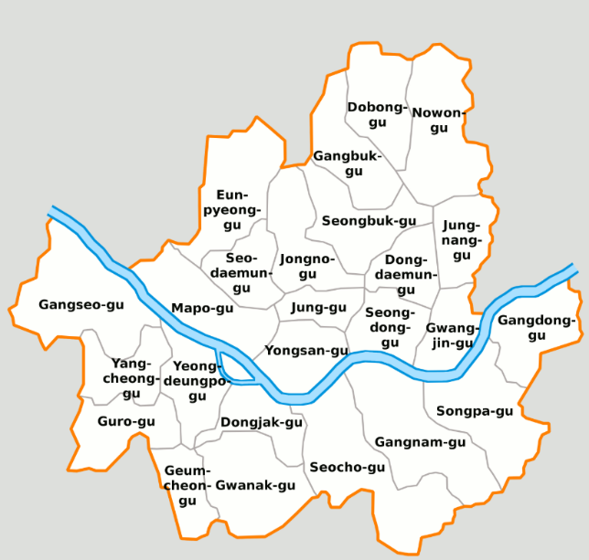Fig. 2. Map of Seoul with districts. [[link]](https://en.wikipedia.org/wiki/File:Map_Seoul_districts_de.png)

So, our goal is found best "Dong" for starting a new coffee shop using Foursquare location data. We may use location data for Seoul additionally.

1. Methodology

2.1 Exploratory data analysis

I will use 2 datasets. First is the geographic data of Seoul. It contains District and Dong names and its latitude, longitude information. Second one is Foursquare location data, with Foursquare API. We can get information of venues in Seoul.

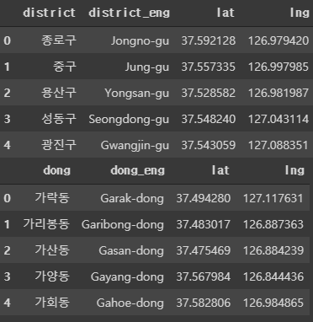Let’s check geographic data first. It has names of District, Dong and their lat, lng information. Also I have boundary json file of Seoul, districts, Dongs. At Fig. 3., blue circles mean the locations of each Districts of Seoul, and Fig. 4., blue dots mean the locations of each Dongs.

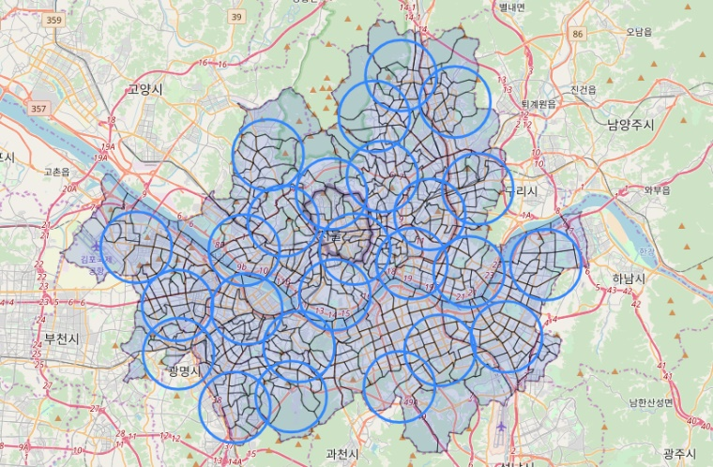Fig. 3. Map of Seoul using boundary data(25 Districts).

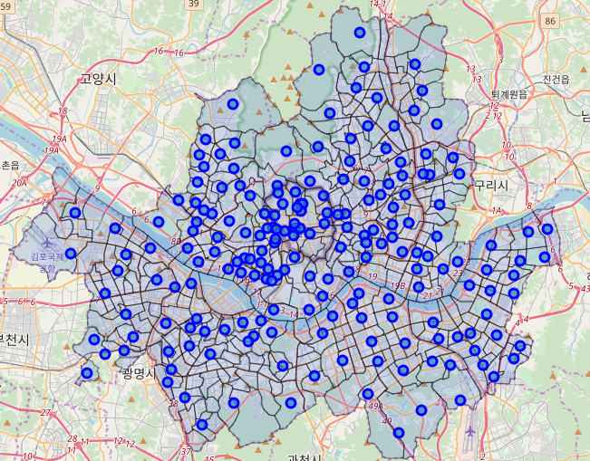

Fig. 4. Map of Seoul using boundary data(198 Dongs).

|  |  |
| --- | --- |
| District Name | # of Dongs |
| Jongno-gu | 18 |
| Mapo-gu | 13 |
| … | … |
| Dobong-gu | 3 |
| Geumcheon-gu | 3 |

Of all Districts, Jongno-gu has 18 Dongs, but Geumcheon-gu has only 3 Dongs.

Using FourSquare API, I can get the information of 4,707 venues in Seoul.

|  |  |
| --- | --- |
| Category Name | # of venues |
| Korean Restaurant | 643 |
| Cafe | 285 |
| Coffee Shop | 270 |
| Chinese Restaurant | 217 |
| Japanese Restaurant | 180 |
| … | … |

There are Coffee shop and Coffee-shop-like categories, like Café, Bakery, Dessert shop, Donut shop, Bubble Tea shop. So, I can separate Coffee shop and Not Coffee shop.

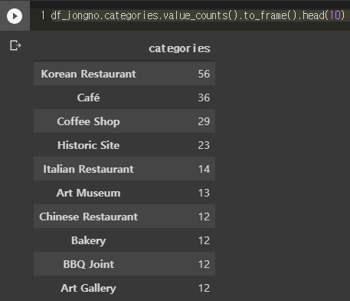As mentioned above, Jongno-gu has 18 Dongs, so Jongno-gu can be a good example for showing my methodology. At Jongno-gu, I can get 471 venues from Foursquare API, and there are 56 Korean Restaurants, 36 Cafés, 29 Coffee shops, etc.

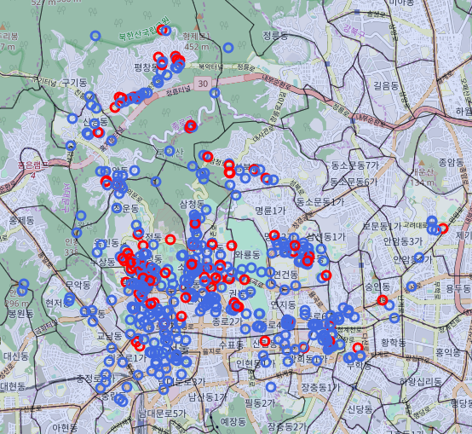Let’s plot Coffee shop and Not Coffee shop venues.

Fig. 5. Map of Jongno-gu with venues(471 venues).

Red circles show Coffee shop venues and blue circles show Not Coffee shop venues. We can get insight that a place with a lot of red circles are fiercely competitive place and a place with a lot of blue circles are less competitive place for coffee shop. None of circles means that there are none of venues, and not suitable for coffee shop.

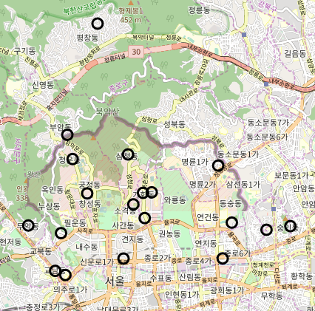We also have Dong information of Jongno-gu.

Fig. 6. Map of Jongno-gu with Dong(18 Dongs).

Let’s make score for each Dong about starting Coffee shop. There are two standards for scoring. First is that the Dong, far from existing Coffee shop, get high score. And second, the Dong, close from existing Not Coffee shop, get high score.

So I calculate distance of every Dongs between center of Dongs and each venues using latitude and longitude data. After that I counted the number of Coffee shop and Not Coffee shop with in 1KM from center of each Dongs. Scoring is simply calculated by number of Not Coffee shop subtract number of Coffee shop.

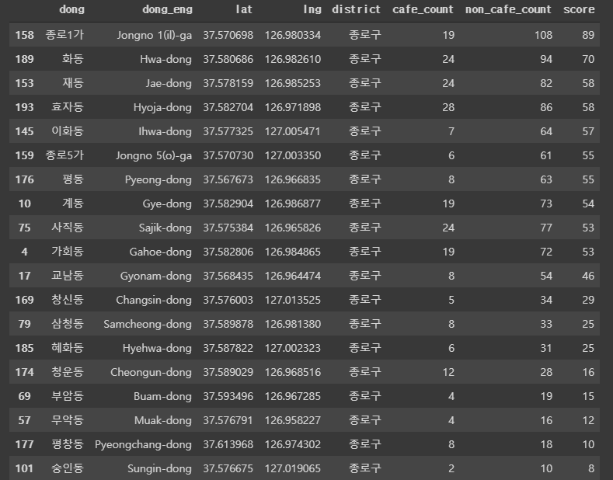

Fig. 7. Score table of Jongno-gu.

As the result, “Jongno 1(il)-ga” get the highest score, and “Sungin-dong” get the lowest score. Fig. 7. shows venues of Jongno-gu. Blue circle represents “Jongno 1(il)-ga”, the best place for Coffee shop in Jongno-gu, and grey circle represents “Hwa-dong”, the 2nd best place, and red circle represents “Sungin-dong”, the worst place.

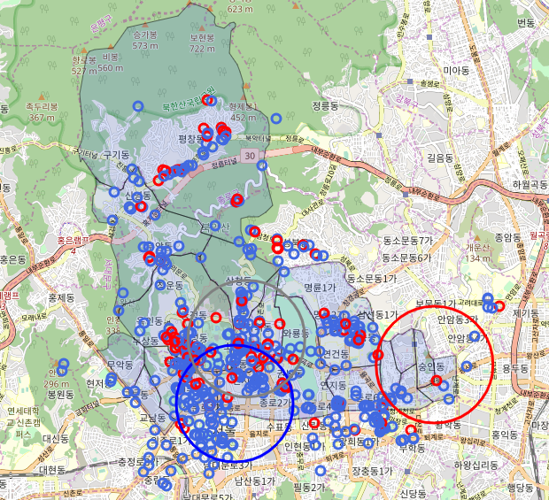“Jongno 1(il)-ga” and “Sungin-dong” has almost same Coffee shop / Not Coffee shop rate. However “Jongno 1(il)-ga” has lots of venues(127) and “Sungin-dong” has only 12 venues. So I can make difference between these to Dongs.

Fig. 7. Map of Jongno-gu with scoring results.

1. Results

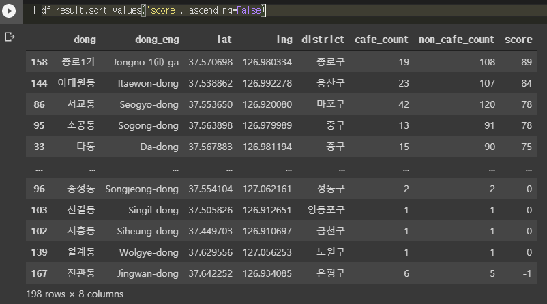We checked the result of Jongno-gu, and it is quite acceptable. So let’s move on to the whole of Seoul.

Fig. 8. Score table of Seoul.

“Jongno 1(il)-ga”, “Itaewon-dong”, “Seogyo-dong”, “Sogong-dong”, “Da-dong” got best 5 and “Songjeong-dong”, “Singil-dong”, “Siheung-dong”, “Wolgye-dong”, “Jingwan-dong” got worst 5. Let’s visualize the result.

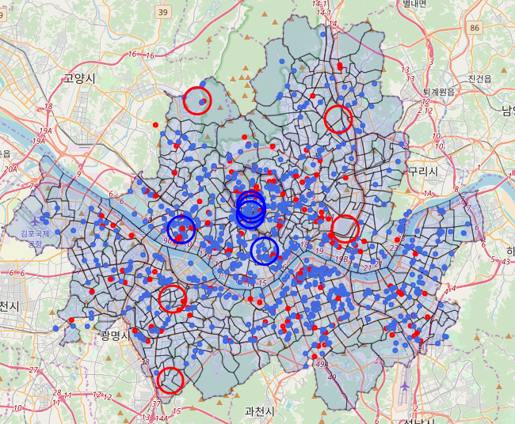

Fig. 9. Map of Seoul with scoring result.

Fig. 9. shows the result. 5 blue circles show 5 best places for Coffee shop, and 5 red circles show 5 worst places for Coffee shop in Seoul. As you can see, blue circles locate center of Seoul and contain a lot of venues, on the other hand, red circles contain a few of venues.

1. Discussion

Although the results have been obtained, it should be noted that there is a problem with the dataset. In particular, there is a lack of venue datasets. Although I brought venue data using Foursquare API, many Korean venues are not registered because this service is not used much in Korea. And because famous places have a lot of venue data, and few places don't, I think this imbalance has had a huge impact on the results. According to recent Korean statistics, the number of coffee shops in Seoul is close to 20,000. Therefore, it is necessary to interpret the results by referring to these points.

1. Conclusion

In this project, we used the venue data provided by Foursquare to find the best place to succeed as a coffee shop in South Korea. As a result, the place that people generally visited was a lot of venue data, and these places received the highest score. On the contrary, places where people visit less often get lower score. However, since Korea is a country that does not use much Foursquare, a lack of venue data can be problem. Thus, data gathering is needed to reinforce the result.